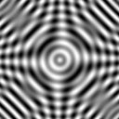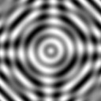

B = 0.2; S = 1.2

B = 0.2; S = 1.0

B = 0.2; S = 0.8

B = 0.2; S = 0.6

B = 0.2; S = 0.4

**Figure 1.** For a fixed bandwidth of 0.2, the sampling rate value was used in the range [0.4, 1.2] at steps of 0.1 sfu. From left to right the displayed images show the cases of the even values of S allowing a gradual evaluation of the quality and sharpness of the zoomed-in image.